The Museum of the Broads
Stalham Staithe
Stalham
Norfolk
NR12 9DA
Learning Resource Pack

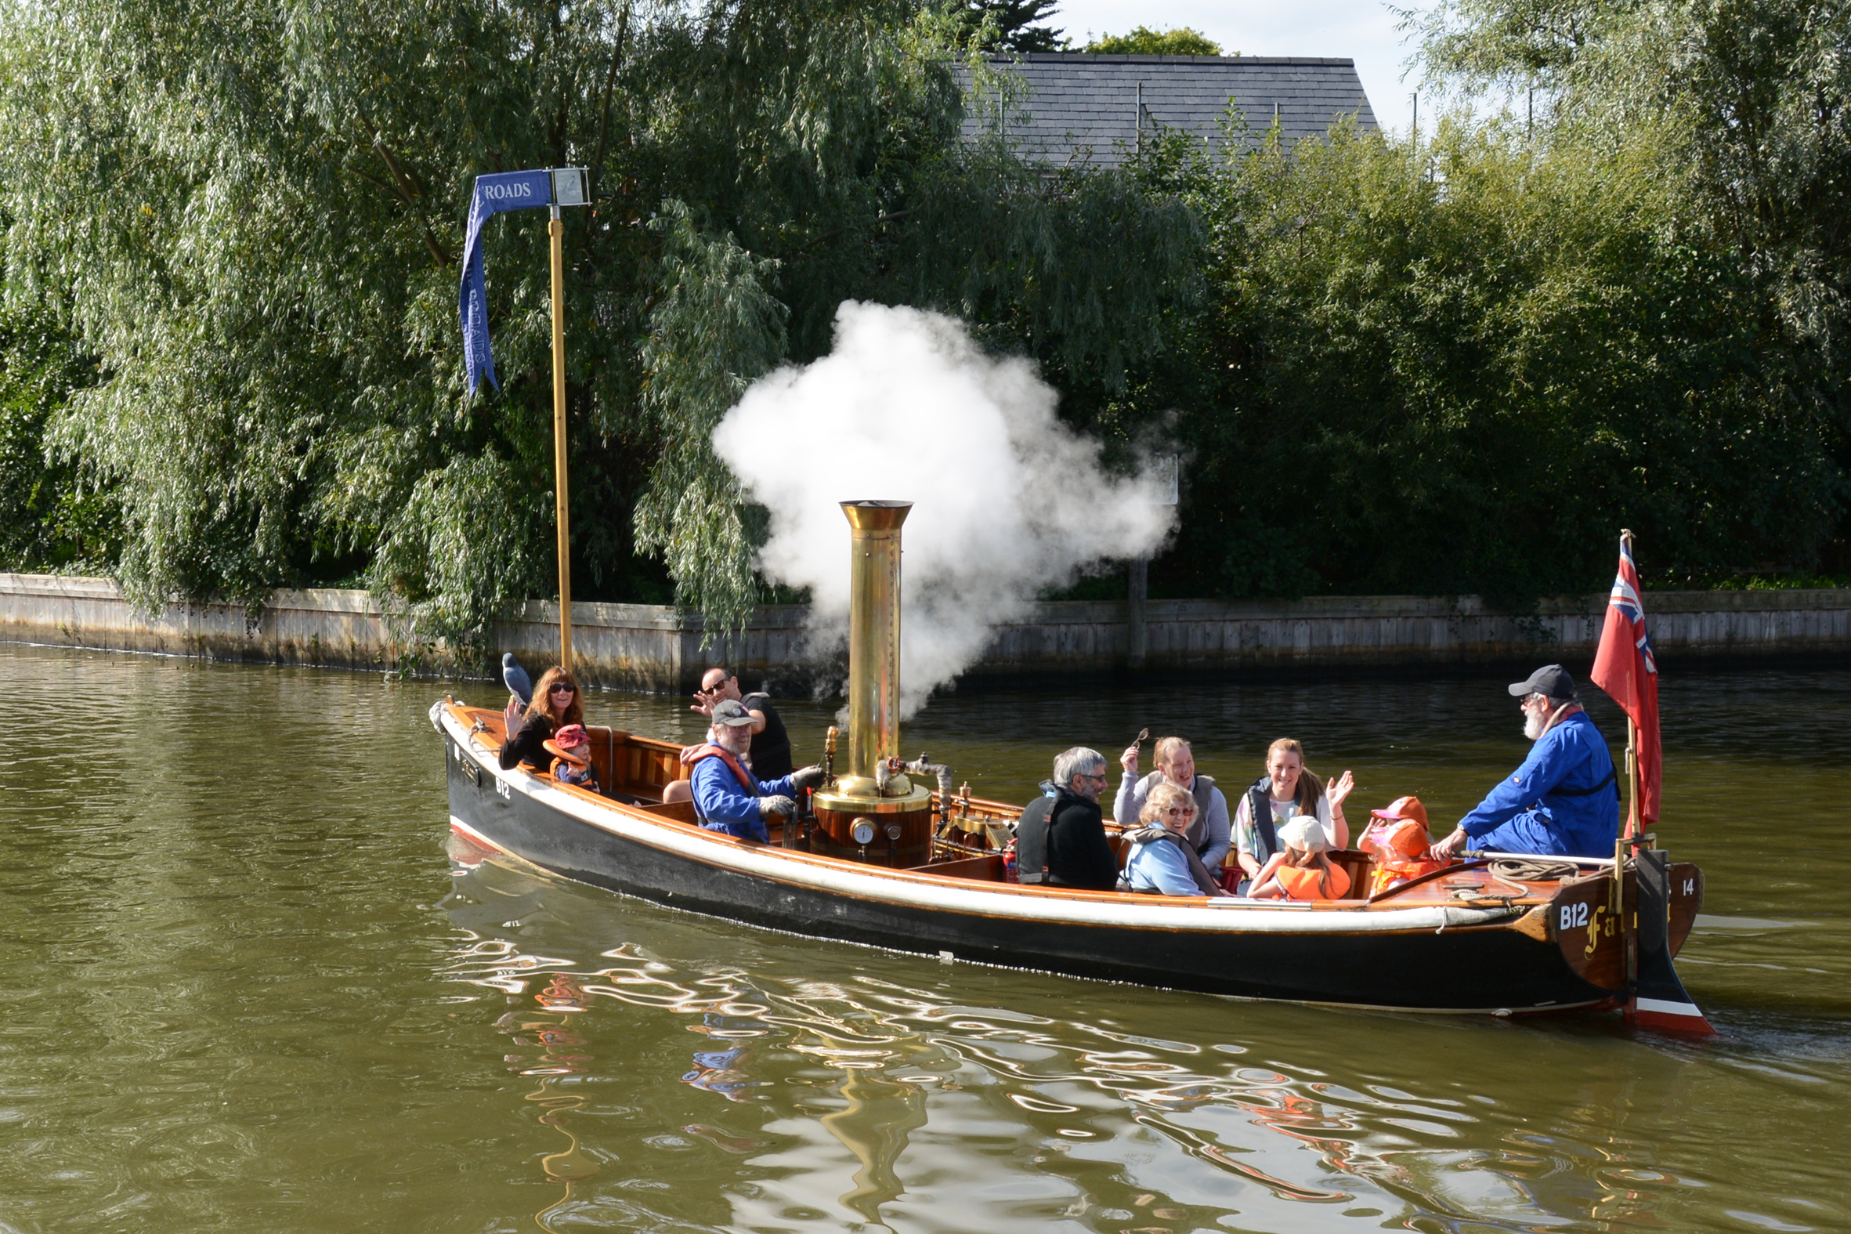
The Victorian Steam Launch, ‘Falcon’
The Museum of The Broads
Learning Pack
The ideas and worksheets in this pack will give you an insight into the activities that can take place during and after a visit to the Museum.
The ideas and worksheets included in this pack are for inspiration and can be copied for use in the classroom or at the Museum. Most of the worksheets are devised to be used on site, but feel free to modify them as is necessary for your group. Some worksheets are produced to be used in one building, others will need the children to move within the entire site to solve the problems. Some are 'wordy', some are not.
We have found it best that a class of up to 35 is most suitable for this site. However, we have had double that number at the Museum and with careful organisation this will work.
The Museum is also open to the public and this must be remembered when bringing a group. Our volunteers and Curator will help you to plan your visit.
The Museum has a selection of hand magnifiers, binoculars, tape measures, magnets and work boards so that the children can work in groups on different activities throughout the site. We also have several trails on a trail sheet.
There is a grassed area by the river where children can have a picnic and see wildlife or feed the ducks (we do not sell duck bread!). We also have covered areas if wet. There is a shop where children can buy small souvenirs (pens, postcards, pencils, key rings, rubbers and so on) of their visit. We also sell crisps, drinks and ice creams so please tell us if your children are not allowed to buy these.
The cost per child is presently £2 a head. This kept low as we understand the cost of hiring a coach. We also have a unique Victorian Steam Launch, Falcon, and an electric boat, Marsh Harrier. Both boats seat 10. We run short (20mins) river trips for schools at a cost of £2 a head. This trip takes children along the river past Richardsons Boatyard towards Barton Broad. Both boats are crewed by qualified personnel and buoyancy aids are provided for all children and adults. Children and adults are assisted on and off the boat, down purpose built steps.
If you wish to book a visit or request more information - email the Museum curator@museumofthebroads.org or telephone the Curator on 01692581681.

We have some handling items and photos for your use too.

There are many more areas that could be highlighted from your visit including:
- The history of boat toilets – and sanitation
- Knots and their uses
- Sailmaking
- Boat design and boat use through the ages
- Bridges and their structure
- Jobs and activities associated with the Broads
- Tourism and its importance to Norfolk
- Landscape Use – Contrasting areas
- The importance of rivers in other times
- The influence of the Railways on the Broads
- The importance of the boatbuilding industry
- Fishing and wildfowling on the Broads
- Conservation and Sustainability
- Our Annual Exhibition for 2022 is From Sails to Blades – How Wind Power Shaped the Broads.

The Museum of The Broads
MARSHMAN’S TOOLS
The Marshman spent his working life on the marshes beside the rivers, dykes and broads. Look Carefully at the Tools. Choose 6 that you like. Draw them, name them and say what they are used for.
Name ...................................  Used for ............................. | Name ....................................  Used for ................................
Name ...................................  Used for ...................... | Name .....................................  Used for ..............................
Name ...................................  Used for .............................. | Name ...................................  Used for ..............................
By …........................................................................
The Museum of The Broads
The Surlingham Room
Look for these animals. Tick when you find each one.
A grey squirrel A swallowtail butterfly A red squirrel
A Coypu A pike A kestral A Swan’s egg

What did a marsh man do on the Broads? Listen to the marsh man.
............................................................................................................................................................................................................................................................................................................................................................................................................................................................
What is his boat called? ......................................................................
What did a windpump do ?.........................................................................
Draw something that you like from this room.

This is ..........................................................................................
By ….......................................................
The Museum of The Broads
LIFE ABOARD A WHERRY
Look in the Wherry Cuddy. This is where the Wherryman and his mate or wife and children lived. Can you see what the Wherry man and his Wife (or mate) used for the following things? Draw a picture of the objects used.
For COOKING | For LIGHTING
For SLEEPING | For EATING

By .......................................................................
The Museum of The Broads
ANIMALS ON THE BROADS
Look around the Museum. You will find pictures, models and information on animals found in the Broads. Draw and colour them carefully. Make sure they are in the right section and you name them.
BIRDS | FISH
MAMMALS | INSECTS

By.........................................................................
The Museum of The Broads
THE MARSHMAN’S YEAR
Look in the Marshman’s Room. Find the large photo of the marshman and listen to the model marshman talk to you. Write down what the marshman does in SUMMER and WINTER. What TOOLS does he use in each season?
SUMMER
JOBS

TOOLS

WINTER
JOBS

TOOLS

By .........................................................
The Museum of The Broads
MARSHMAN’S TOOLS
What different materials are the tools made from?
...................................................................................................................
Some of them are strange shapes. Draw your favourite tools here.

By .................................................................................................
The Museum of The Broads
Maths at the Museum
These ideas can be used in pairs, groups or as a whole class.
Length - Which boat is the longest? The shortest? Can you measure and find out using string, tape measures, hand spans or measuring sticks. There are a number of different objects suitable for this.
Number The children can count the numbers of boats in the Museum. They can devise their own groups or sets, ie. By material (wood, plastic, concrete) by colour, by type, by use).
They can also count:
1) The different types of tools used by the Marshman or the Sailmaker. Who uses the most tools?
2) How many bricks in a square metre on the Surlingham building’s wall? Calculate how many bricks were used to build this building?
3) How many slabs on the path over the grass?
4) How many outboard engines/ inboard engines in the Museum?
5) How many wheels are there (what different types)?
Area
Which area is the biggest? The grass,the path, the tarmac, the decking?
Don’t fall in the water!!
Which of the 4 buildings in the Museum covers the biggest space? How could you work this out?
Shape
Look around for examples of tesselated shapes, bricks, paving slabs
The Museum of The Broads
Length
Work with a partner to help you.
The longest boat is ................ long. It is called...........................................
The shortest boat is .................long. It is called....................................
Write down the length of at least 6 boats. Note them on this chart.
Name of boat | Estimated Length (m) | Measured Length (m)
When you get back in class you can make a block graph or bar chart of you boats. Don’t forget to label the axes and give your chart a title.
Find 6 other objects that you would like to measure the length of: tools, animals, toilets (!),paths, fences or whatever you want. Record them here.
Object | Length | Object | Length

The Museum of The Broads
Geography Ideas
Mapping- The children can draw a sketch map of the Museum site, not to scale but with colours or symbols to show different areas, buildings or uses.
Mapping – The children can map the layout of one particular building and produce a key to show the objects in that building /room.
In the classroom: Using LANDRANGER 134 Norwich and The Broads maps allow the children( in pairs or threes) to explore the map and find out the names of the rivers, the Broads, the villages, the connecting road numbers, the railway stations, etc.
Included in this pack is a sample worksheet 1 that can be used with top Juniors or lower Secondary students.
Mapwork Using the large Broads map in the Surlingham building, children could investigate the area of the Broads. (Worksheet 2)
Questionnaires - Ask the children to devise a survey to find out about the visitors, their ages, the distance they have travelled, how they got to the Museum, where they have came from, their favourite part of the Museum, etc. This is a fairly difficult task for children and they will need lots of discussion and group ideas. They could use IT to publish it and choose the most successful questionnaire.
Visitor Attractions – The children could find out which other visitor attractions there are in the immediate area covered by the LANDRANGER 134. Have they been to them? Which is the best? Could they produce a school survey to find out what other children in school enjoy most, least?
Using promotional leaflets, which are free from TI Centres, will remind the children about local attractions. Some are available from the Museum.

The Museum of The Broads
Literacy Ideas
Accounts of the Visit – predictable but as an information or account format still useful.
Descriptive Writing – Choose one object in the Museum to describe without saying what it is, see if the other children can guess.
Poems- Acrostics, mood poems based on the five senses whilst sitting in the Museum (one verse for each sense but without using the words see, feel, hear,etc), Colour poems ( collect examples of objects in one colour to use as a poem in class), Haiku, Kennings, Riddles, shape poems
Brochures- Design a leaflet or promotional brochure to advertise the Museum or the Broads as a holiday destination. What needs to go in it? Good collaborative groupwork. Use IT to publish leaflet.
Stories – Choose a character from the Museum, Marshman, River Inspector, Sailors in Maria, Wherryman to write about their job, a day in their life or a problem they might have on the Broads.
Drama – based on a character, a situation, a scene that could happen in the Museum ( the noisy visitor, someone in the water, the complaining customer, a lost child) or on The Broads ( boat sinking, boat adrift, lost luggage, a strange creature spotted, bird watching, kite flying, etc)
Persuasion – Write or give a talk to persuade someone why they might/or might not want to have a holiday on the Broads (or why someone might visit/or not visit the Museum). Collect ideas in small groups as discussion focus and children can produce paired or group work to read out.
A Ghost Story There are lots of ghost stories about the Broads and Marshes, see ‘Ghosts of the Broads’, or visit during the Hallowe’en period.
Museum or Broads Alphabet – see worksheet
Recipes – A Good (Bad) Museum Trip, A Good (Bad) Broads Holiday. List ingredients-as strange as possible (a cloudless sky, a hot sun, a large picnic). Then write instructions using Instruction Verbs (Mix, Stir Add, Sift, Shake,etc)
Photostory – Using digital photos taken at the Museum, give each child a set of images to write a story of their Museum trip. This could be paired or group work. Produce a booklet to display in zig- zag form.

The Museum of The Broads
Worksheet 1 – LANDRANGER 134 Name......................................................
Look carefully at the map and see what you can spot!
1. What colour are town names? ..........................................
2. What colour are River names? ..........................................
3. Write down the names of as many Broads as you can find
..........................................................................................................................................................................................................................................................................................................................................................
4. Write down the names of as many Rivers as you can find
..........................................................................................................................................................................................................................................................................................................................................................
5. Which Broad does the River Ant run through? …..................................
6. Which River runs through Beccles? ….................................................
7. The River Bure runs through C............ …..,H.............. & H.................
8. The River Yare runs through B...................... and R............................
9. Draw symbols for: a station a heliport
a marsh a river
an A road a B road

10. Write down all the railway stations you can see
.....................................................................................................................
.....................................................................................................................
11. Draw symbols for a camp site a caravan site
12. Which Rivers flow into Great Yarmouth and into the sea?
.............................................................................................................
13. Which large Broad is west of Lowestoft? …...........................................

The Museum of The Broads
Art and Design Ideas
Observational Drawing on site, using graded pencils and/or charcoal of boats, tools, animals, models, buildings, objects.
Poster Design - To advertise the Broads or The Museum. Use Railway posters available in the shop ( as posters or cards) as inspiration. Choose a Museum object to focus for poster.
Boat Models- Using found materials, plastic bottles for hulls, sticks for masts, design and make a wherry, sailing boat, canoe, Inspectors launch, steam launch.
Boat Design - Design a fantastic holiday cruiser for a family holiday. Take photos of boats from Blakes, Hoseasons, Richardsons, Herbert Woods, Martham Boat Development catalogues.
Boat Nameboards - Look at the ‘Name Boards’ in the Museum of boats and Wherries to see different styles of lettering and design. Children produce their own. Similarly with wherry ‘Jenny Morgans’
Boatyard Flags and Badges. Each boatyard had its own pennant and badge. The yards were usually based on the owners names. (Browns, Percivals, Herbert Woods, Wards. )Examples of these are in the Discovery Room. Children could draw and then design one based on their own name in a simple triangular pennant.
Broadland Dioramas -Using a small box ( cereal box, shoe box), create a Broadland scene using coloured paper, tissue paper, string, wool, cardboard, cut out boats, create windmills, hanging birds, butterflies, trees, reeds. Build up the scene from the background by applying cut outs and models in the foreground.
Weaving - Using simple rectangular card looms, weave a simple Broads scene using coloured wool, raffia, string, coloured plastic strips, old material strips etc. Weave in reeds, buttons, twigs, found materials to create a 3 D effect.
3D Models - The animals, birds and insects of the Broads provide inspiration for modelling. Try giant insects using wire or cane, string, coloured papers; clay or papier mache birds; tinfoil fish using old takeaway trays.
Collage -Produce a large class or group landscape of the Broads. On card(from boxes,cereal packs) make individual collages using wool, string,seeds,etc of a bird, insect, boat, fish, mammal of the Broads

The Museum of The Broads
Worksheet 2 – to be used with Broads Map in Marshman's Room
1. Which boatyard originally produced this map?........................................................
2. How many rivers are shown here? Name them........................................................
…....................................................................................................................................
3. Name 10 Broads shown on this map.......................................................................

4. How many road bridges can you see? .............Name 2 ….........................................
5. Where can you find a ferry ? …..............................and …..........................................
6. Why are bridges and ferries important?.................................................................
…......................................................................................................................................
7. What other types of bridge cross the rivers and roads? …........................................
8. How many Inns of Hotels can you find? ….................................................................
9. Name the inn or hotel at: Coltishall.............................Ludham.................................
Thurne …...................Hickling Broad.............................Cantley..................................
Loddon …............................Geldeston.............................. Upton..................................
10. How many miles from Banhams Yard, Horning is it to:
Potter Heigham Bridge?............. Barton?.................... Beccles?................
Ludham Bridge?......... Whitlingham?............... Coltishall Bridge...................
11. Where are there Early Closing days on Thursdays?................................................
….............................................................................................................................
12. What do you think Early Closing Days were? ….........................................................
13. What do the red numbers on the map mean? ….......................................................
14. Where are the 'Ends of Navigation'?........................, …...................................
…............................................., …........................................., ….............................
15. What does the 'End of Navigation' mean? ….............................................................
…....................................................................................................................................
16. Where is there a Dangerous Bridge …...............................................
WELL DONE YOU HAVE FINISHED! ARE YOU CORRECT?

